Meijiao Li

997793624

Stark Industries

EEC 134B

Applications note for Radar Project

1. Tx/Rx antennas design

The antenna is a very important part of the radar system. In this project, I chose to use infineon BGT24MTR12 chip. The working bandwidth for the chip is from 24 GHz to 26 GHz. I chose to use a patch antenna for the system because it has the simplest structure and easy circuit implementation. Normally, the patch antenna will have about 4 dB directivity and a little lower gain. In our design we chose to use patch antenna array to increase the gain.

a. The patch antenna array structure is shown below.

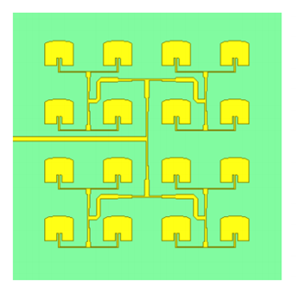

I used a four times four patch antenna array for both the transmitter and receiver part.

b. Patch antenna array return loss simulation results

The figure below shows the return loss of the antenna array design

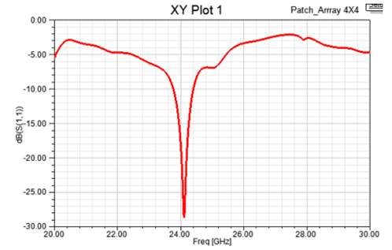

From the plot, we can find that the return loss of antenna array is about 28 dB near 24 GHz. This means that the antenna transmits a lot of power near 24 GHz. Therefore, the array design is sufficient. We considered the differences between the simulation and fabrication results when tuning the array. We also did some tuning for our array to get several different design among the 24 GHz to 26 GHz. When we send out our design to the fabrication company, we chose four array designs. In this way, we can make sure at least one of the array will work perfectly in 24 GHz to 26 GHz system band.

c. patch antenna array farfield pattern simulation results

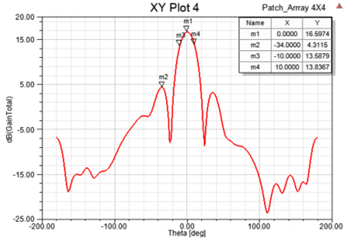

The plot above is the E-plane far field antenna simulation results.

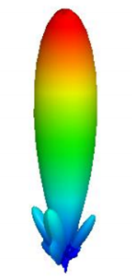

The figure above showed the 3-D far field pattern of the antenna array.

From both the figures, we can find that, the antenna array has a high 16.6 dB gain. And the main lobe is about 12 dB higher than the side lobe.

2. Infineon Transceiver PCB design

The pins of Infineon chip is shown below:

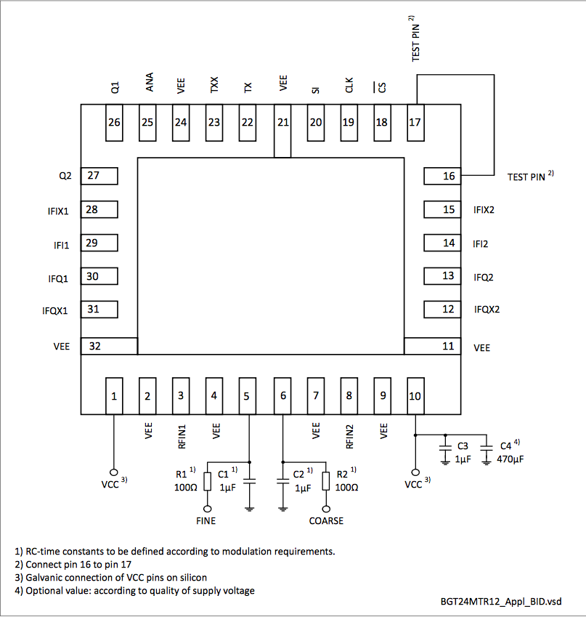

By referencing the pin arrangement and considering the antenna array directivity, Hao and I design the Infineon pcb.

a. The schematic of the infineon transceiver

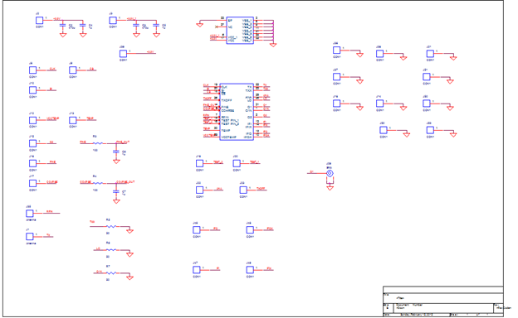

b. The layout of the infineon transceiver

1. Top layer

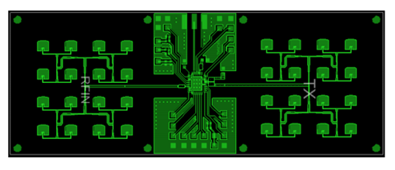

2. Top layer with the bottom layer

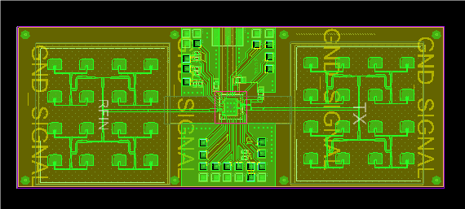

3. Patch antenna array return loss test

The antenna array return loss testing is very important in the whole radar system testing, because it decided what frequency will work in our transceiver and what voltage value we need to send to the VCO in the infineon.

As I designed four arrays and fabricated them, I test all of them to decide which antenna we will use in our radar system

Array A:

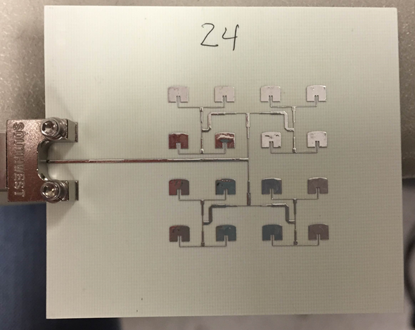

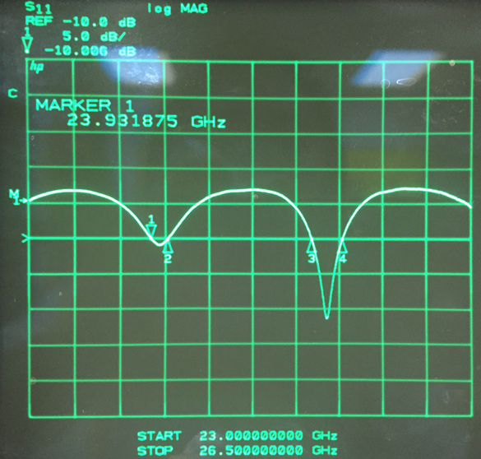

Array B:

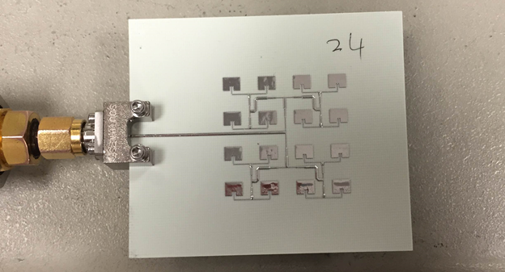

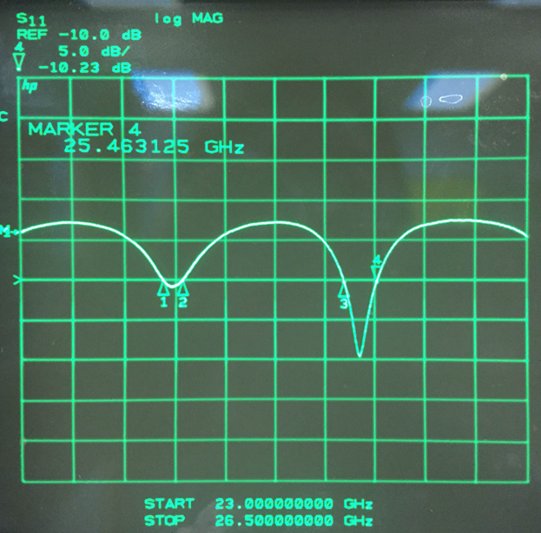

Array C:

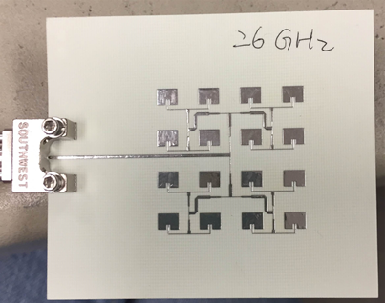

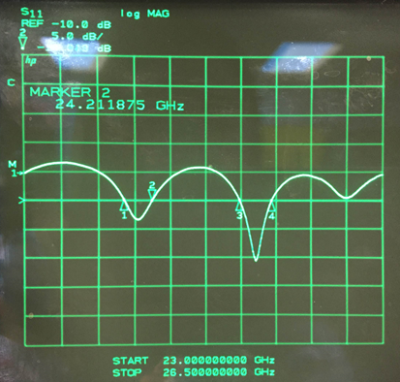

Array D:

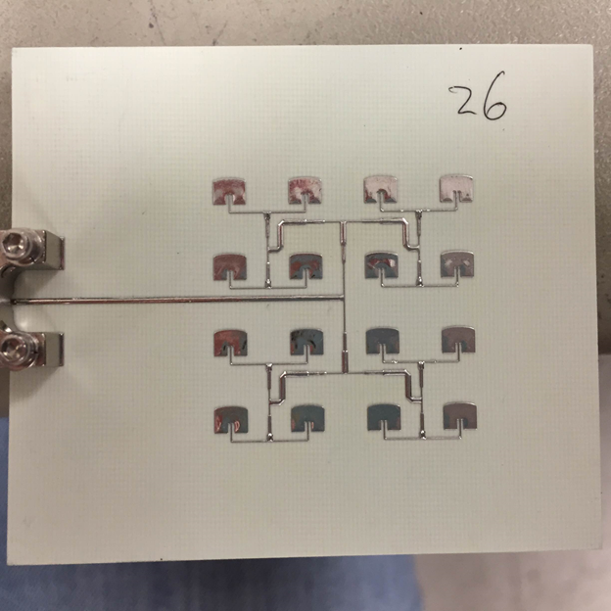



At last, I chose the Array C and D for our radar as they have the best return loss and bandwidth.

4. Test Patch antenna array Far-field pattern in the Anechoic Chamber in Kemper 3rd floor

In this part, Christian and I tested the antenna array together. We only test the Array C and Array D as I decided to try this two type arrays in our system.

In the testing procedure, we met some problems at the beginning. When we first tried to test the array, I did not pay much attention on the polarization of the array. We did not set the direction of E-plane of the array same as the E-plane of the horn antenna, which gave us wrong and very low results. After change the direction of the horn antenna, we got good results.

As Christian had shown lots of pictures of our testing and calculation in his application notes, I will not repeat it in my application notes.

In Christian’s notes, there is one small mistake about our testing which is the far-field of the E-plane, as he chose 24 GHz frequency to plot. In my array design, the antenna bandwidth is 25.2 GHz to 25.5 GHz. Following is the 25.2 GHz E-plane Far-field pattern of out array:

The measurement pattern matches my simulation results very well.

5. Infineon board soldering

In the soldering part, there one thing we need to pay attention, the direction of the headers. As our antenna transmits and receives the power in the direction above the board surface, we are better to finish the soldering and wire connection under the board. The two picture below showed my soldering.

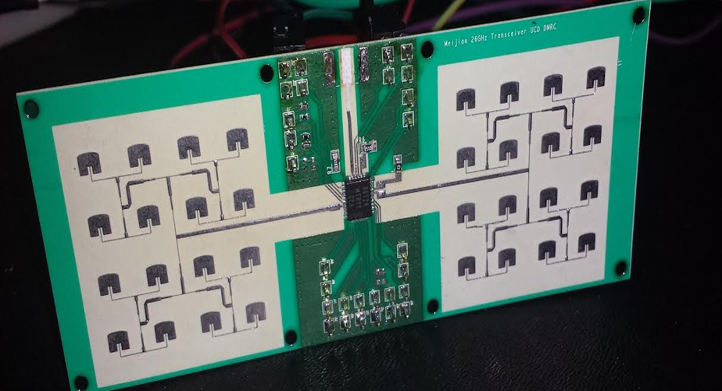

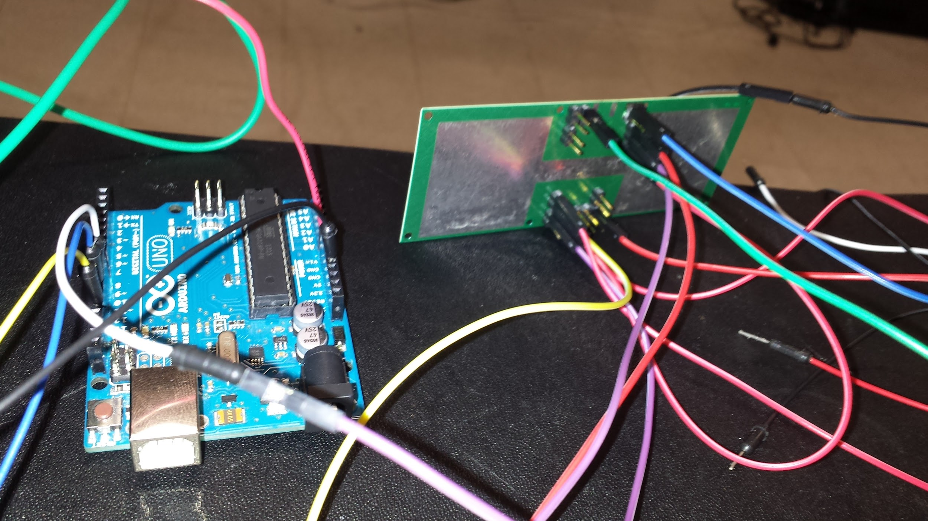

6. System setup and test

For the system test, we did it step by step.

First James checked his IF board works good and test about the filter and Amplifier bandwidth. And then, I made sure the Infineon board works well by testing pin Q1 which is used to monitor the frequency of the oscillation. The Q1 pin is 16 times prescaler of the transmitter output. By testing the Q1 pin, we can have an idea if the chip works and what the frequency it work at. I sweep the input voltage of the fine pin and coarse pin. In this way, we can control the communication frequency by the VCO. From the spectrum analyzer, we can find, by change the voltage of the fine and coarse pin, the frequency of the Q1 pin changed. For the system testing, we write down the value of the input voltage corresponding to 25.2 GHz/16, 25.35GHz/16, and 25.5 GHz/16. The values are 2.1 V, 2.25 V and 2.4 V. This is why I changed the triangle wave code to:

for (int a = 1715; a <= 1960; a=a+1)

for (int a = 1960; a >= 1716; a = a-1)

For the range testing, we try to use the whole bandwidth of the antenna. For 2.1 V = 1715/4084\*5V, 2.4 V = 1960/4084\*5V, so we change the range of “a” to 1715 and 1960.

For the other detail of the whole testing, please reference our lab report, thanks.